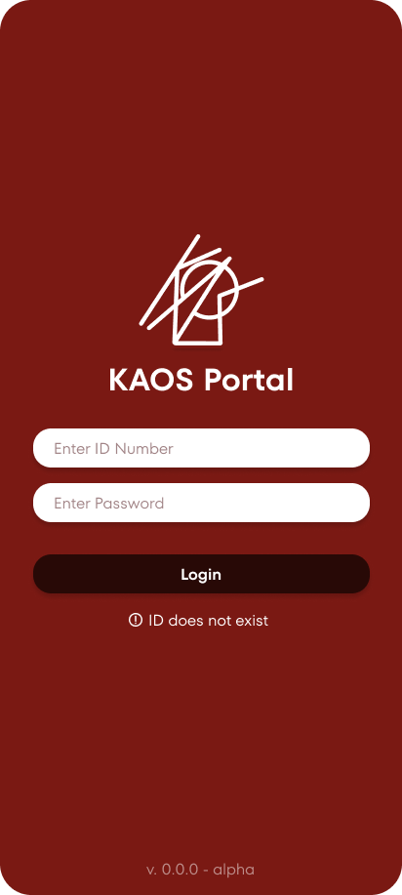
Figure 1. Employee Portal Login
This is the login interface for employees. Users are required to enter their Employee ID Number and Password to sign in to the portal.
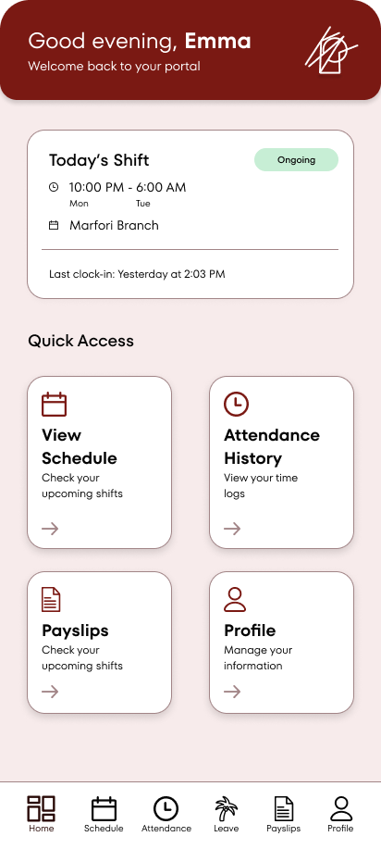
Figure 1.1. Portal Dashboard/Home
This is the main dashboard screen that employees see after logging into the KAOS Portal. It greets the user by name, displays their current shift details (including time, branch, and status), last clock-in information, and provides quick access cards to key features: View Schedule, Attendance History, Payslips, and Profile.
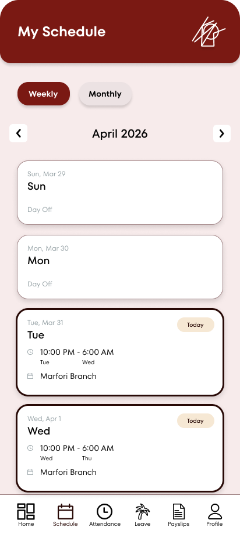
Figure 1.2. Portal Schedule (Weekly View)
The weekly view of the employee’s schedule, showing upcoming shifts with date, time, and assigned branch. Today’s shift is highlighted for easy reference.
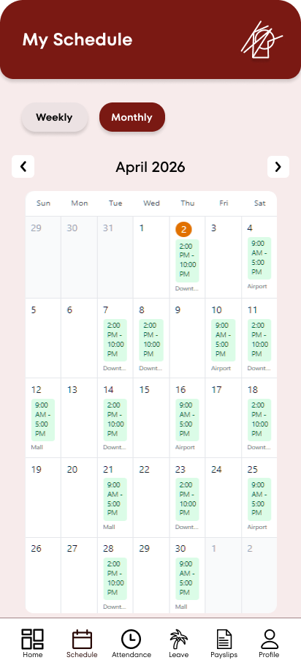
Figure 1.2.1. Portal Schedule (Monthly View)
This screen shows the monthly calendar view of the employee’s schedule for April 2026. Each day with a scheduled shift displays the shift time and branch location. The current day is highlighted with an orange circle for easy identification.

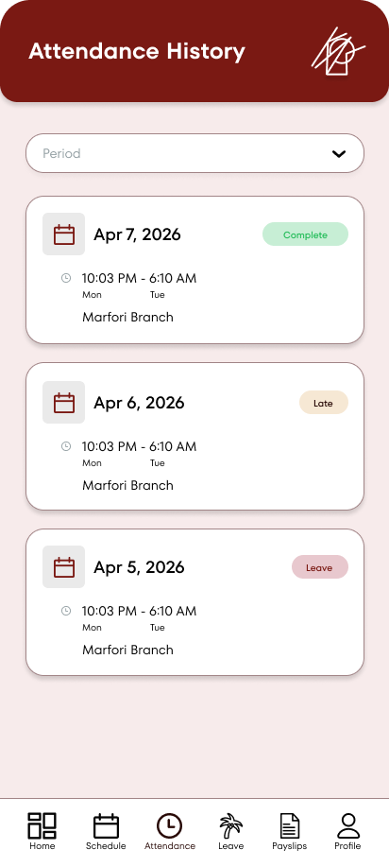
Figure 1.3. Attendance History
A list of the employee’s previous attendances with status indicators per shift, along with shift-specific information.
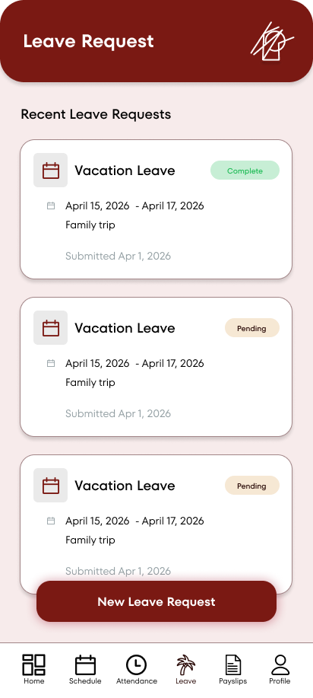
Figure 1.4. Leave Request
Shows a list of recent leave requests and a New Leave Request button.

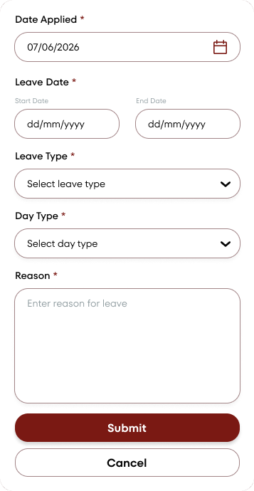
Figure 1.4.1. New Leave Request Form
This is the pop-up form that appears when the user taps the "New Leave Request" button. It allows employees to submit a leave application by filling in the date applied, leave period, leave type, day type, and reason.

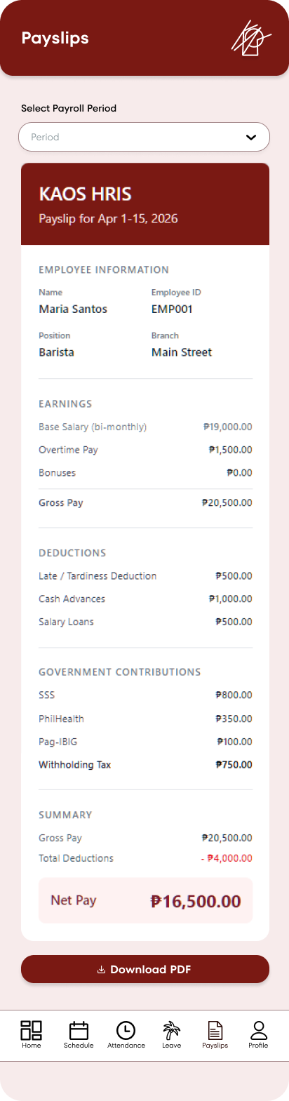
Figure 1.5. Payslips
Allows user to select a payroll period from a dropdown menu and access the payslip details from the selected payroll period with a downloadable PDF.
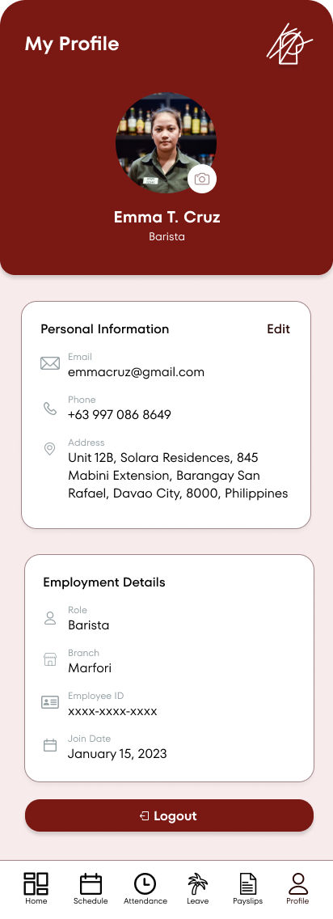
Figure 1.6. Employee Portal Profile
This is the user’s personal profile screen, displaying their photo, basic information, contact details, and employment information. It includes an Edit button for personal details and a Logout option at the bottom.

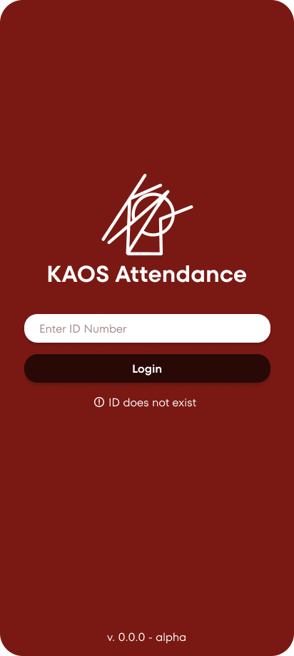
Figure 2. Attendance Portal Login
This is the initial login screen of the KAOS Attendance app, where users enter their Employee ID Number to access the system. It features the app logo, a simple ID input field, a Login button, and displays an error message when the ID does not exist.
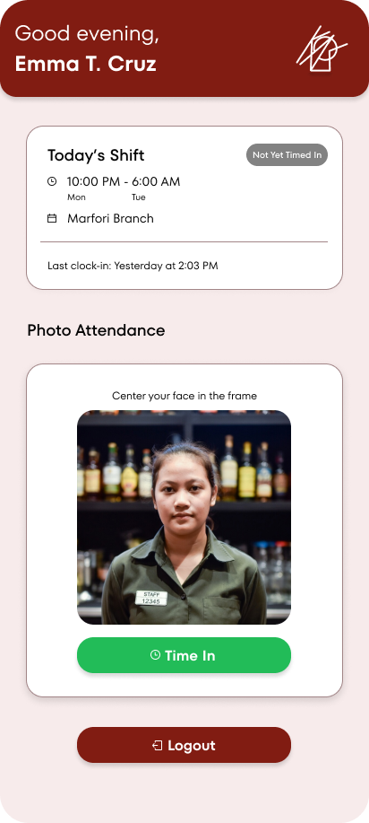
Figure 2.1. Attendance Portal Dashboard
This is the main home screen after login. It greets the employee by name, shows their Today’s Shift details (including time, date, and branch), last clock-in information, and features a Photo Attendance section with a live camera preview for facial recognition. Employees can tap the green “Time In” button to clock in.
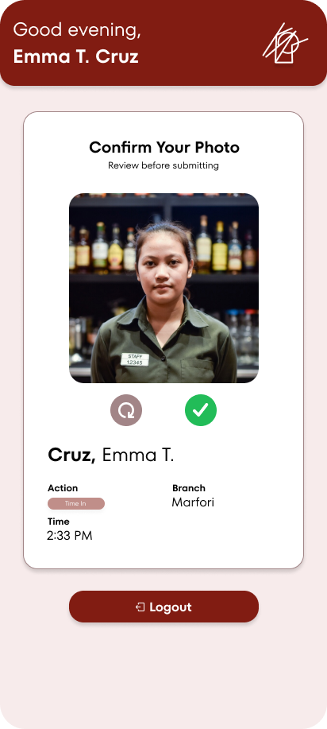
Figure 2.2. Attendance Confirmation
This screen appears right after the employee takes their photo for attendance. It shows a preview of the captured photo, the employee’s name, the action (Time In), branch, and exact time. The employee can review the photo and either retake it (using the refresh icon) or confirm it with the green checkmark before submitting.

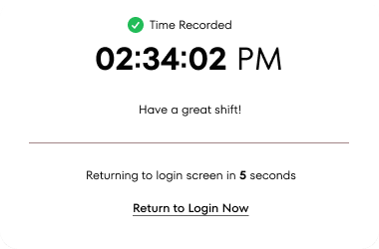
Figure 2.2.1. Attendance Success Pop-up
This is a confirmation pop-up that appears after the employee successfully records their Time In. It displays the exact time recorded, a friendly message, and automatically returns to the login screen in 5 seconds. Users can also tap “Return to Login Now” to go back immediately.

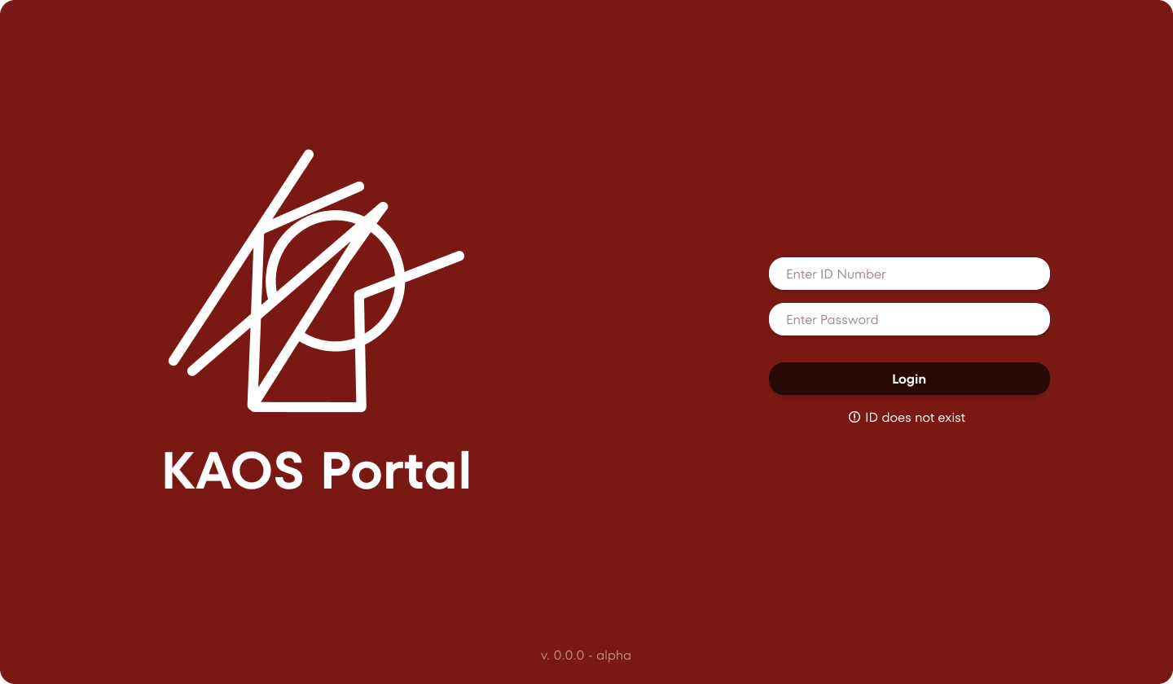
Figure 3. KAOS Admin Portal Login
This is the login screen for the KAOS Portal (admin side). It features the KAOS logo, fields for ID Number and Password, a Login button, and an error message for invalid ID or password.

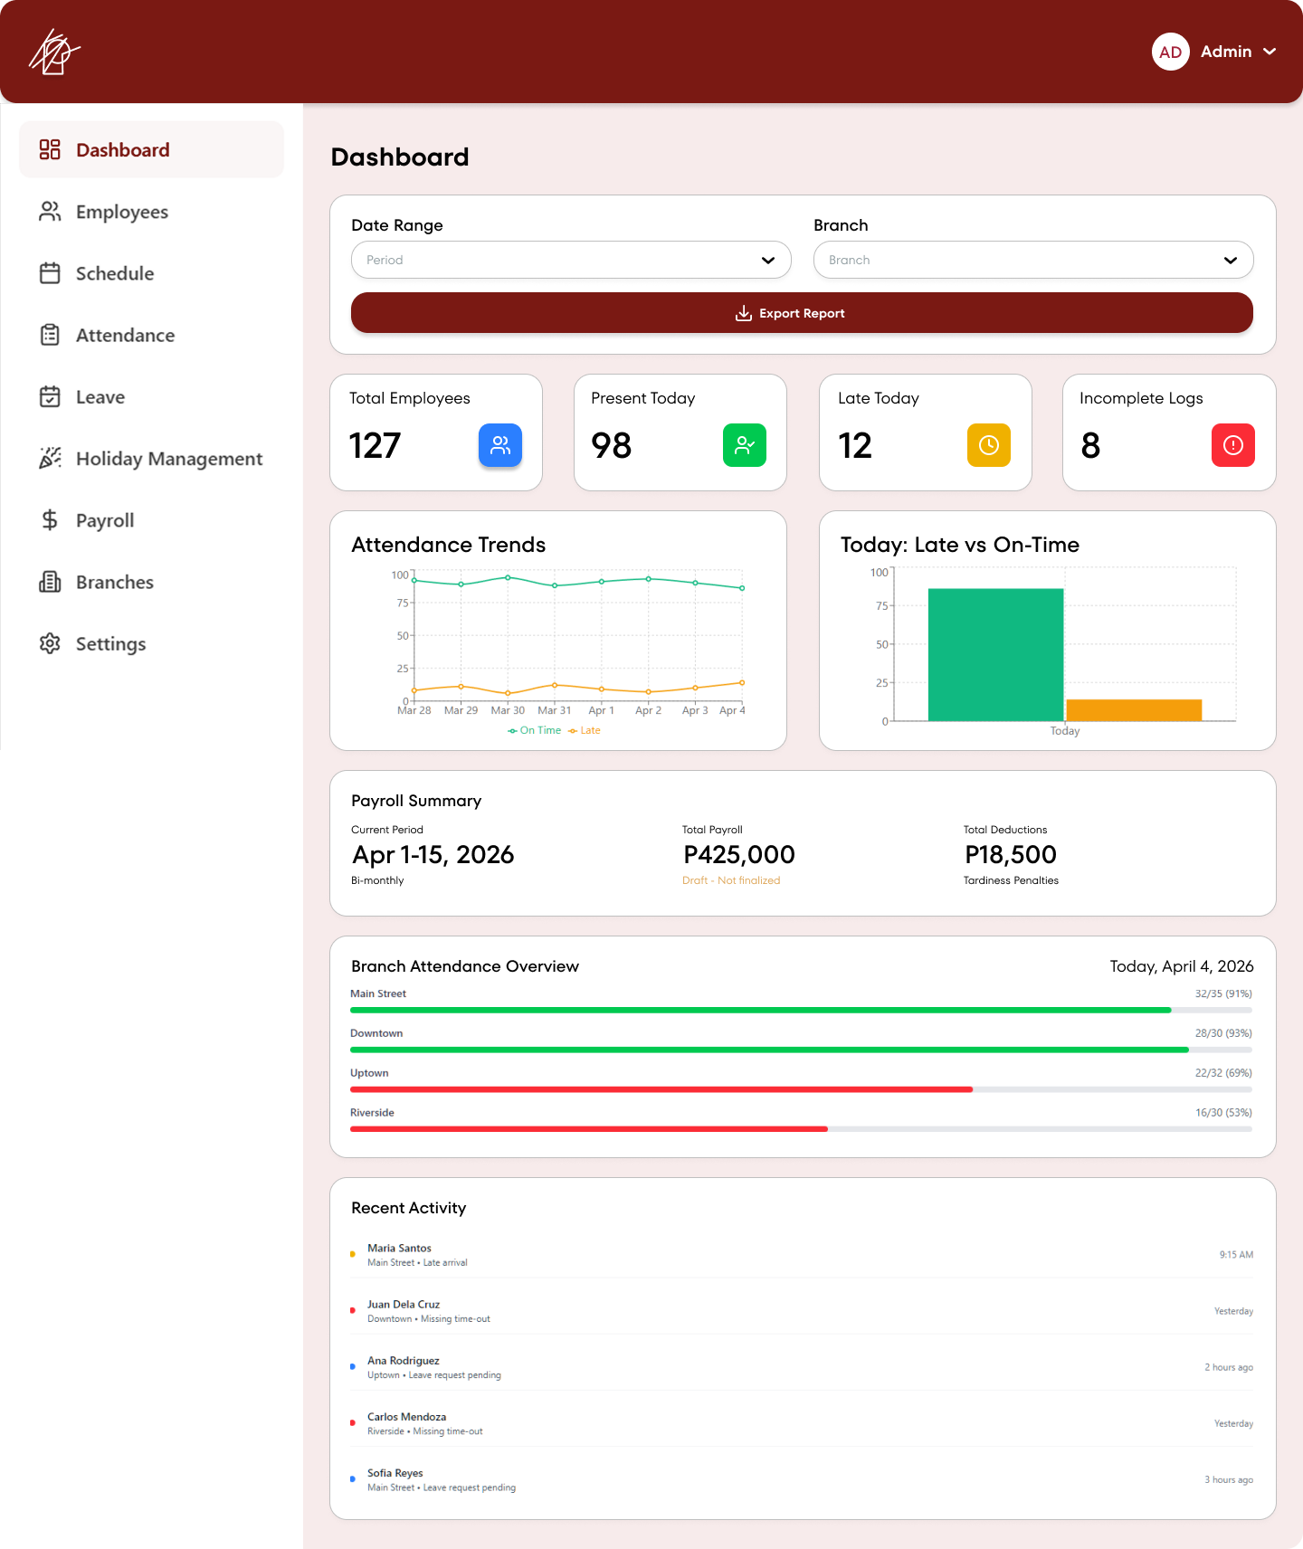
Figure 3.1. Admin Portal Dashboard/Home
This is the main dashboard/home page that appears after the admin logs into the KAOS Portal. It provides an overview of key metrics including total employees, present today, late today, and incomplete logs. It also features attendance trends chart, today’s late vs on-time breakdown, payroll summary, branch attendance overview, and recent activity log.
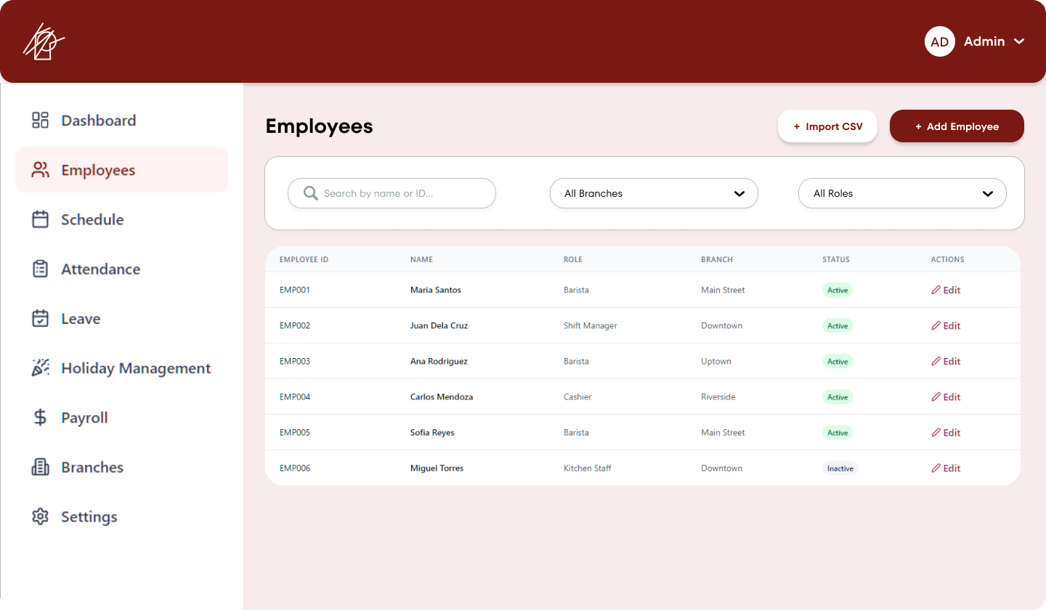
Figure 3.2. Employees Management
This is the Employees management page in the KAOS Portal admin panel. It displays a list of all employees with their Employee ID, Name, Role, Branch, Status, and Edit actions. The page includes search and filter options (by branch and role), as well as buttons to Import CSV and Add Employee.
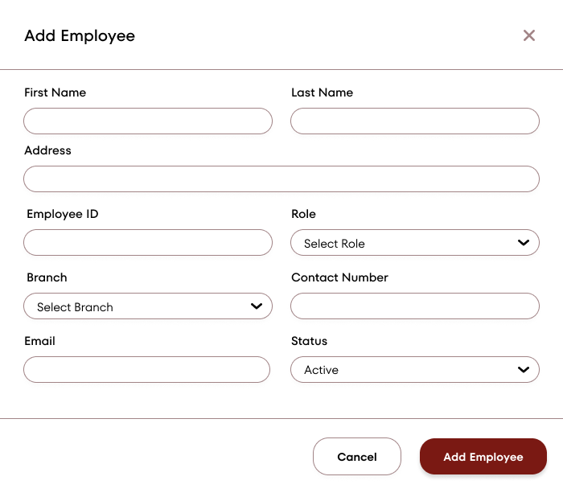
Figure 3.2.1. Add Employee Pop-up Screen
This is the pop-up form that appears when the admin clicks the "+ Add Employee" button. It allows the admin to enter the new employee’s details including First Name, Last Name, Employee ID, Role, Branch, Contact Number, Email, and Status before saving.
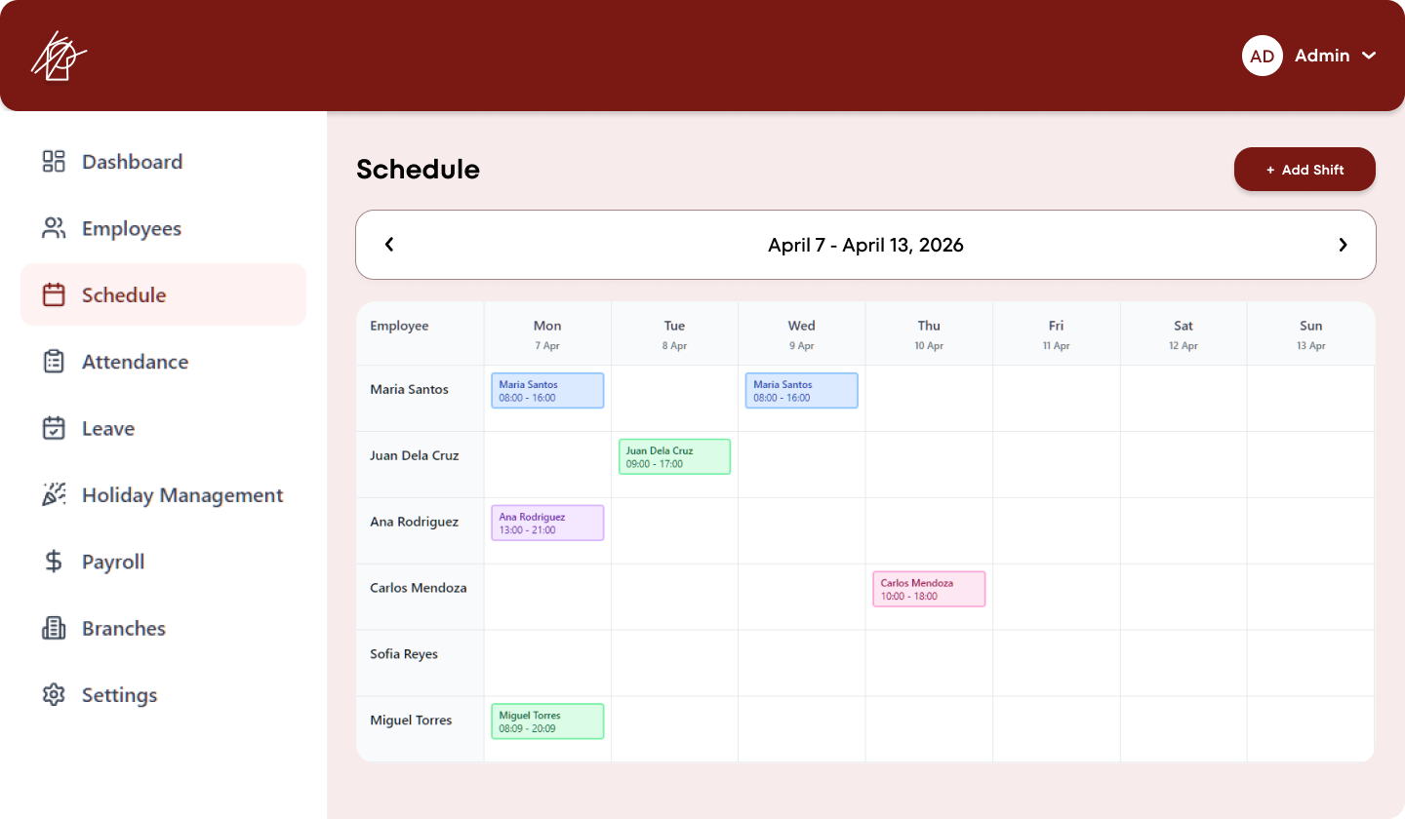
Figure 3.3. Schedule Calendar
This is the Schedule management page in the KAOS Portal admin panel. It displays a weekly view (April 7 – April 13, 2026) of employee shifts, showing assigned working hours for each employee across the days of the week. Admins can add new shifts using the "+ Add Shift" button.
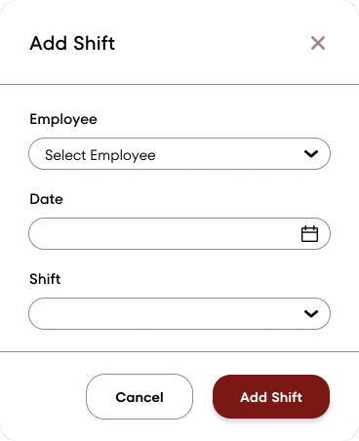
Figure 3.3.1. Add Shift Pop-up Screen
This is the pop-up form that appears when the admin clicks the "+ Add Shift" button on the Schedule page. It allows the admin to assign a shift by selecting the Employee, Day, and Shift time before saving.
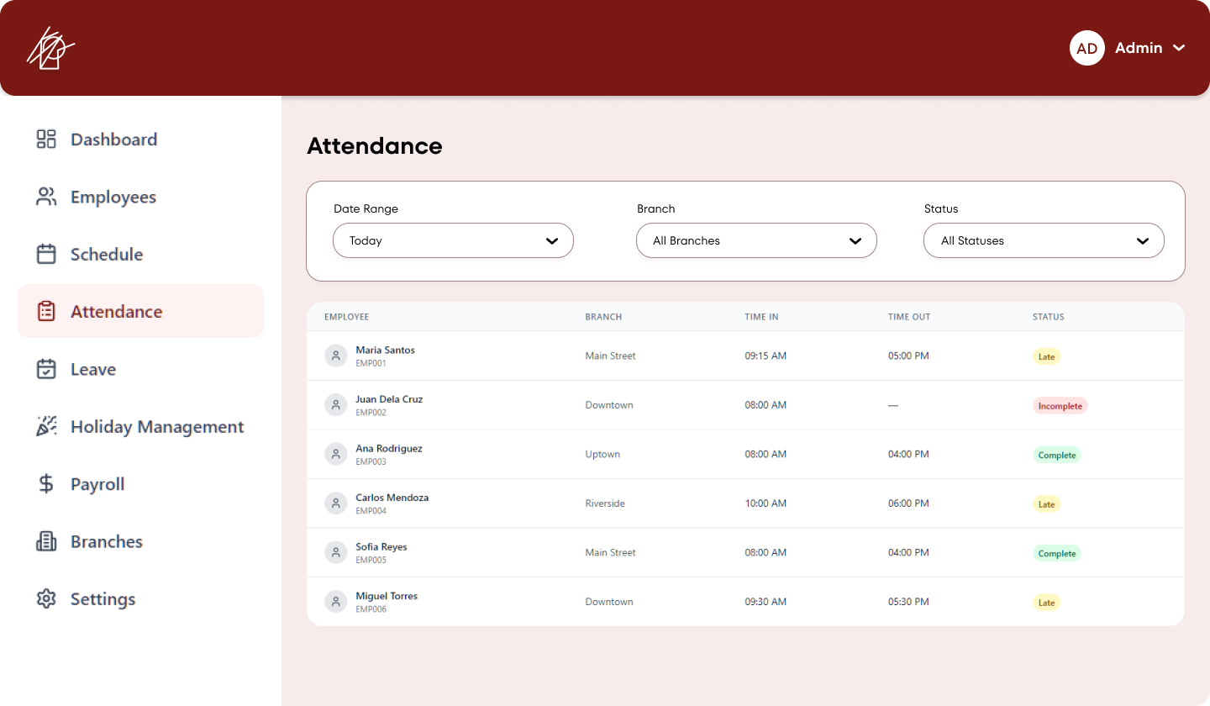
Figure 3.4. Employee Attendance
This is the Attendance management page in the KAOS Portal admin panel. It shows a list of employee attendance records with details such as Employee name and ID, Branch, Time In, Time Out, and Status (Complete, Late, or Incomplete). Admins can filter the records by Date Range, Branch, and Status.
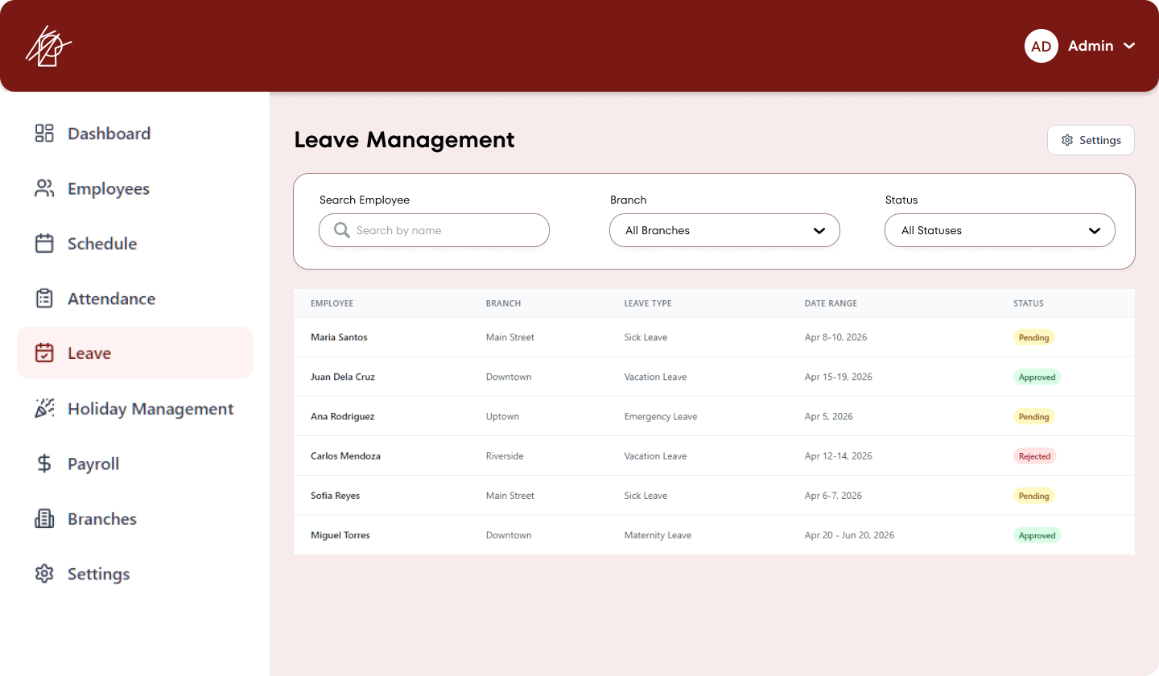
Figure 3.5. Leave Management
This is the Leave Management page in the KAOS Portal admin panel. It displays a list of all employee leave requests with details such as Employee, Branch, Leave Type, Date Range, and Status (Pending, Approved, or Rejected). Admins can search by employee name and filter by Branch and Status.
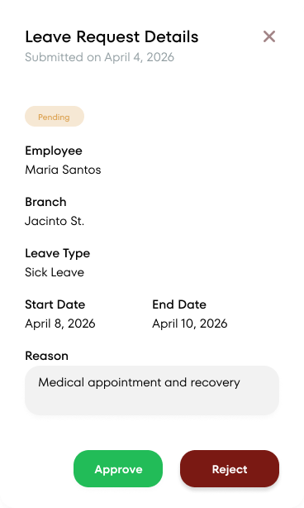
Figure 3.5.1. Leave Request Details Sidebar
This is the pop-up sidebar that appears when the admin clicks on a leave request from the Leave Management page. It shows the full details of the request including the employee name, branch, leave type, date range, reason, and submission date. The admin can then choose to Approve or Reject the request.
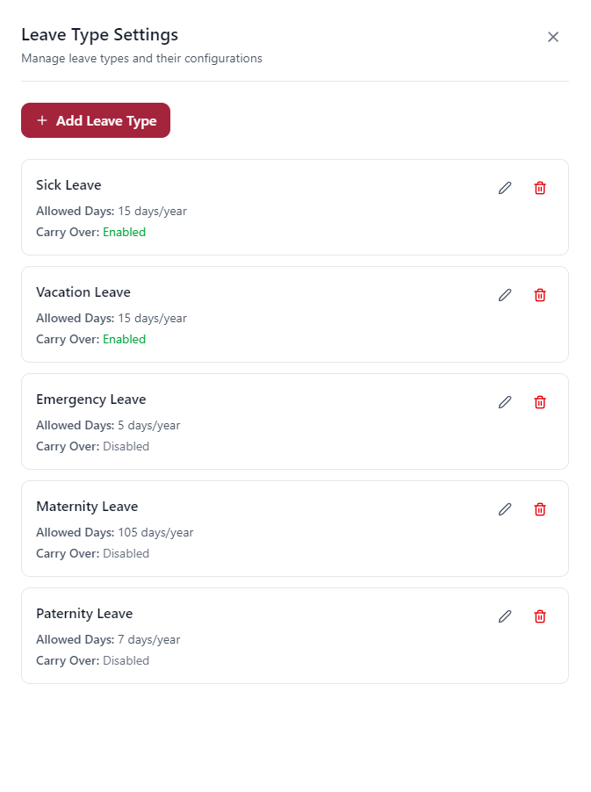
Figure 3.5.2. Leave Type Settings
This is the pop-up that appears when the admin clicks the "Settings" button on the Leave Management page. It allows the admin to manage different leave types, view their configurations (allowed days per year and carry-over status), and add new leave types. Each leave type can be edited or deleted.
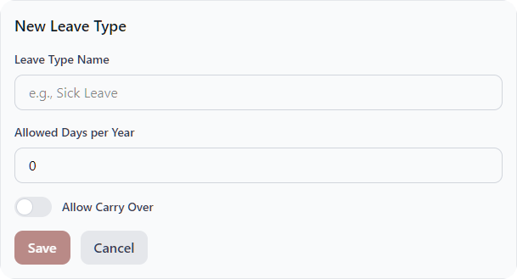
Figure 3.5.2.1. Add New Leave Type
This is the pop-up form that appears when the admin clicks the "+ Add Leave Type" button in the Leave Type Settings panel. It allows the admin to create a new leave type by entering the leave type name, the number of allowed days per year, and toggling the "Allow Carry Over" option.
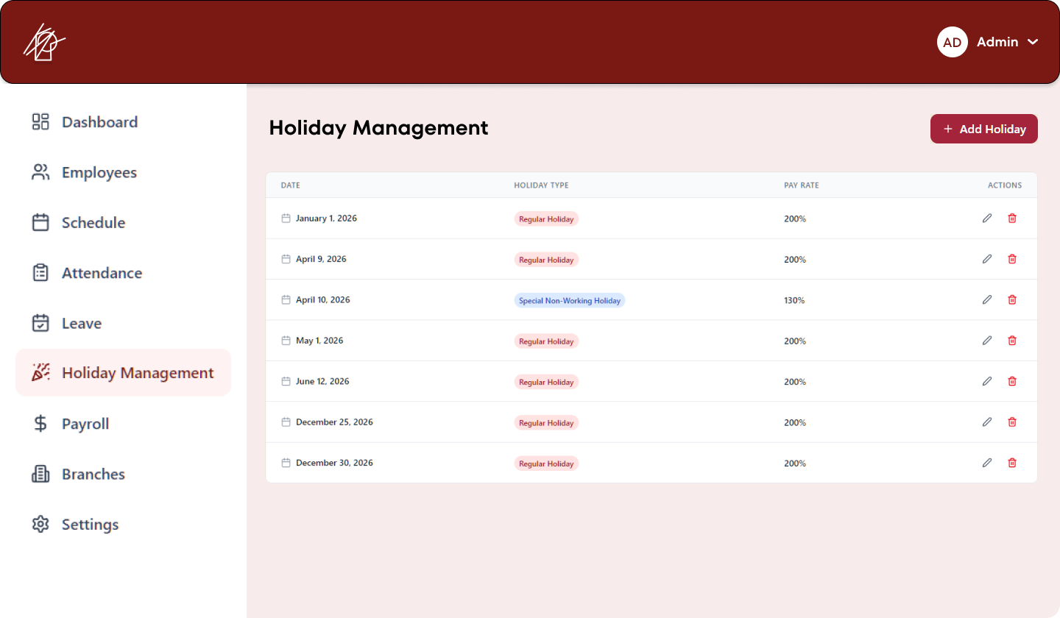
Figure 3.6. Holiday Management
This is the Holiday Management page in the KAOS Portal admin panel. It displays a list of all holidays with their date, holiday type (Regular Holiday or Special Non-Working Holiday), pay rate, and action buttons to edit or delete. Admins can add new holidays using the "+ Add Holiday" button.

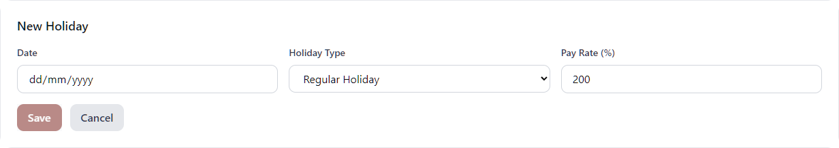
Figure 3.6.1. Adding New Holiday
This is the pop-up form that appears when the admin clicks the "+ Add Holiday" button on the Holiday Management page. It allows the admin to add a new holiday by selecting the date, holiday type (e.g., Regular Holiday), and setting the pay rate before saving.
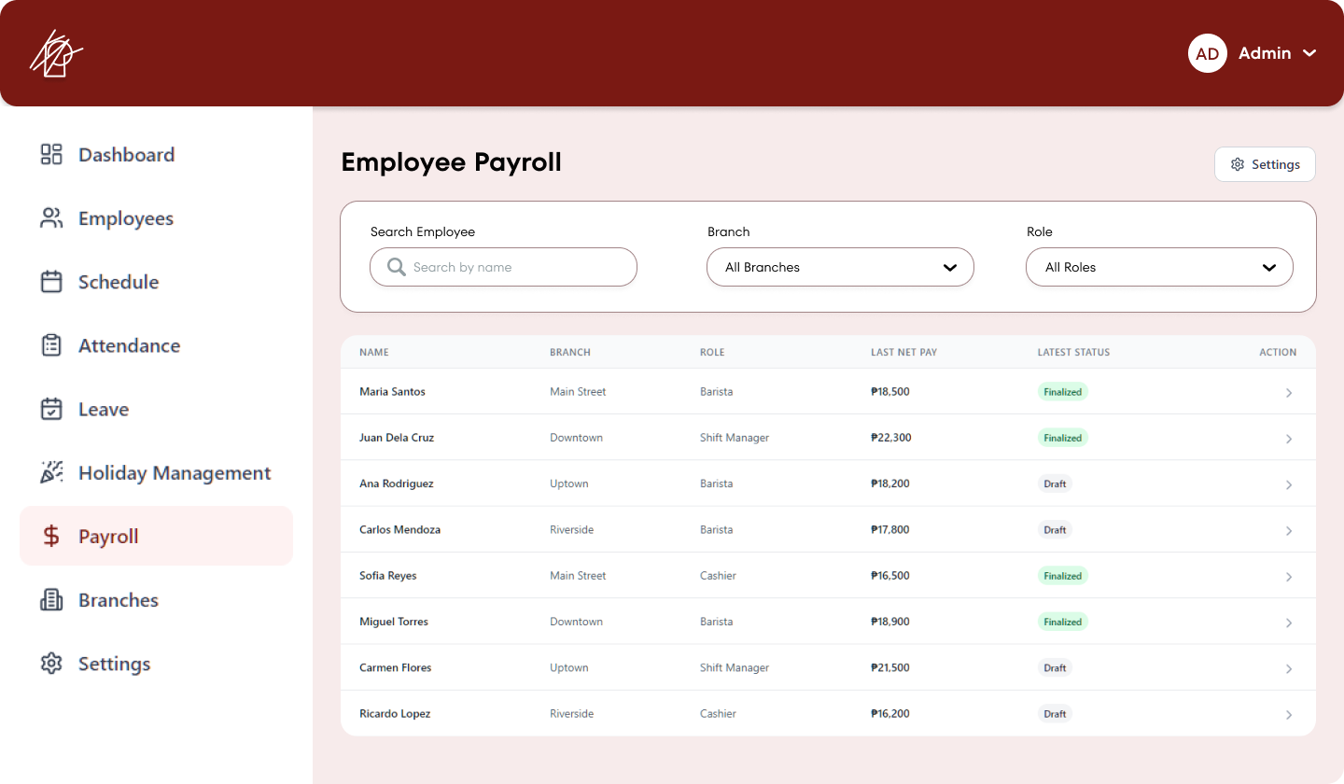
Figure 3.7. Manage Employee Payroll
This is the Employee Payroll page in the KAOS Portal admin panel. It displays a list of employees with their Branch, Role, Last Net Pay, Latest Status (Finalized or Draft), and an action button to view or manage individual payroll details. Admins can search by name and filter by Branch and Role.
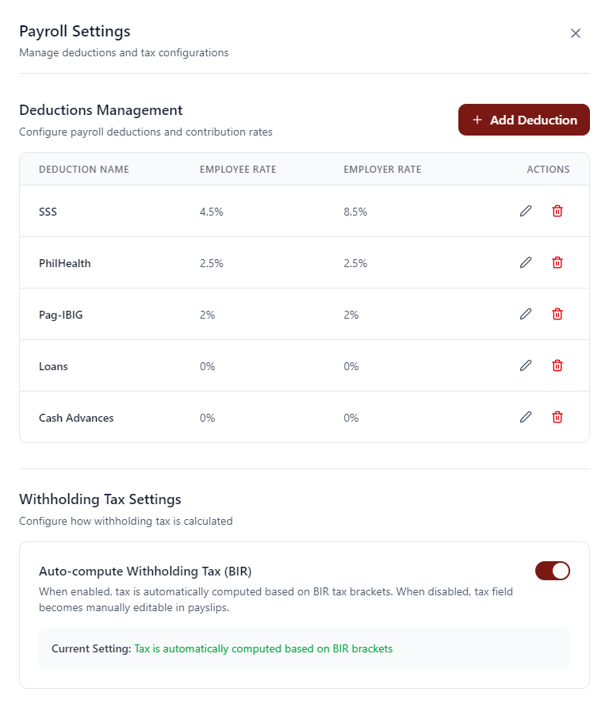
Figure 3.7.1. Payroll Settings Pop-up
This is the Payroll Settings pop-up that appears when the admin clicks the "Settings" button on the Employee Payroll page. It allows the admin to manage payroll deductions (SSS, PhilHealth, Pag-IBIG, Loans, Cash Advances) with their employee and employer contribution rates, and configure Withholding Tax settings (auto-compute based on BIR tax brackets).
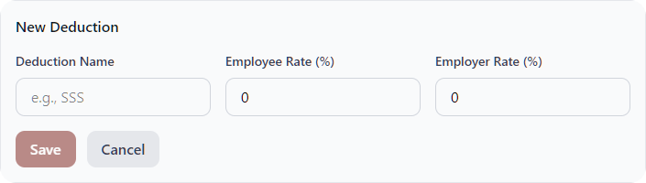
Figure 3.7.1.1. Create New Payroll Deduction
This is the pop-up form that appears when the admin clicks the "+ Add Deduction" button in the Payroll Settings panel. It allows the admin to create a new payroll deduction by entering the deduction name, employee rate (%), and employer rate (%).
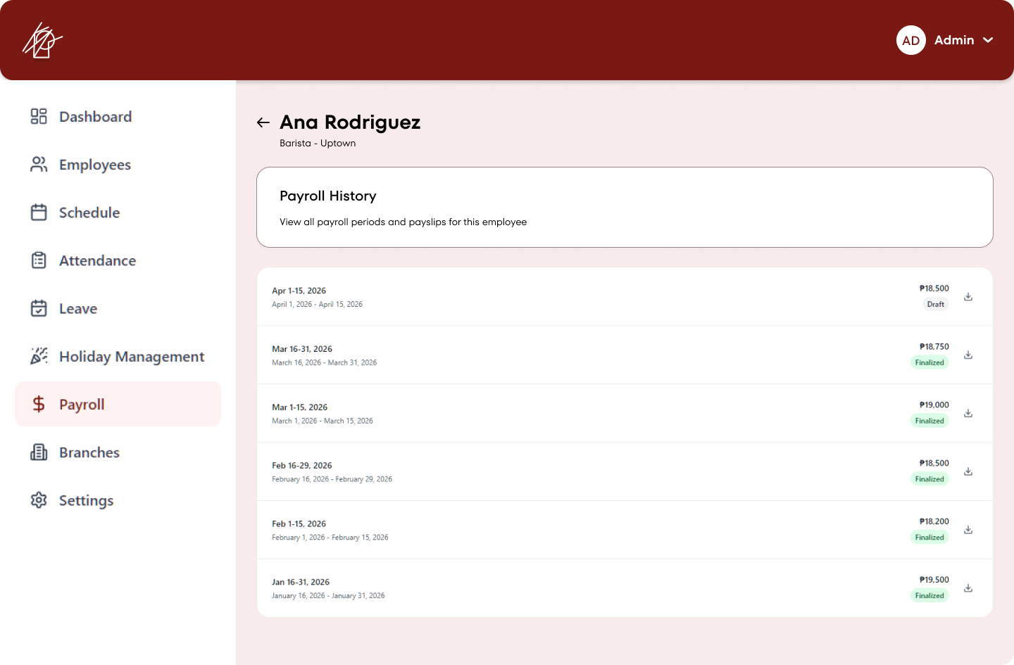
Figure 3.7.2. Employee Payroll History
This screen displays the complete payroll history for a specific employee. It shows a list of past payroll periods with the date range, net pay amount, status (Finalized or Draft), and a download icon for each payslip.
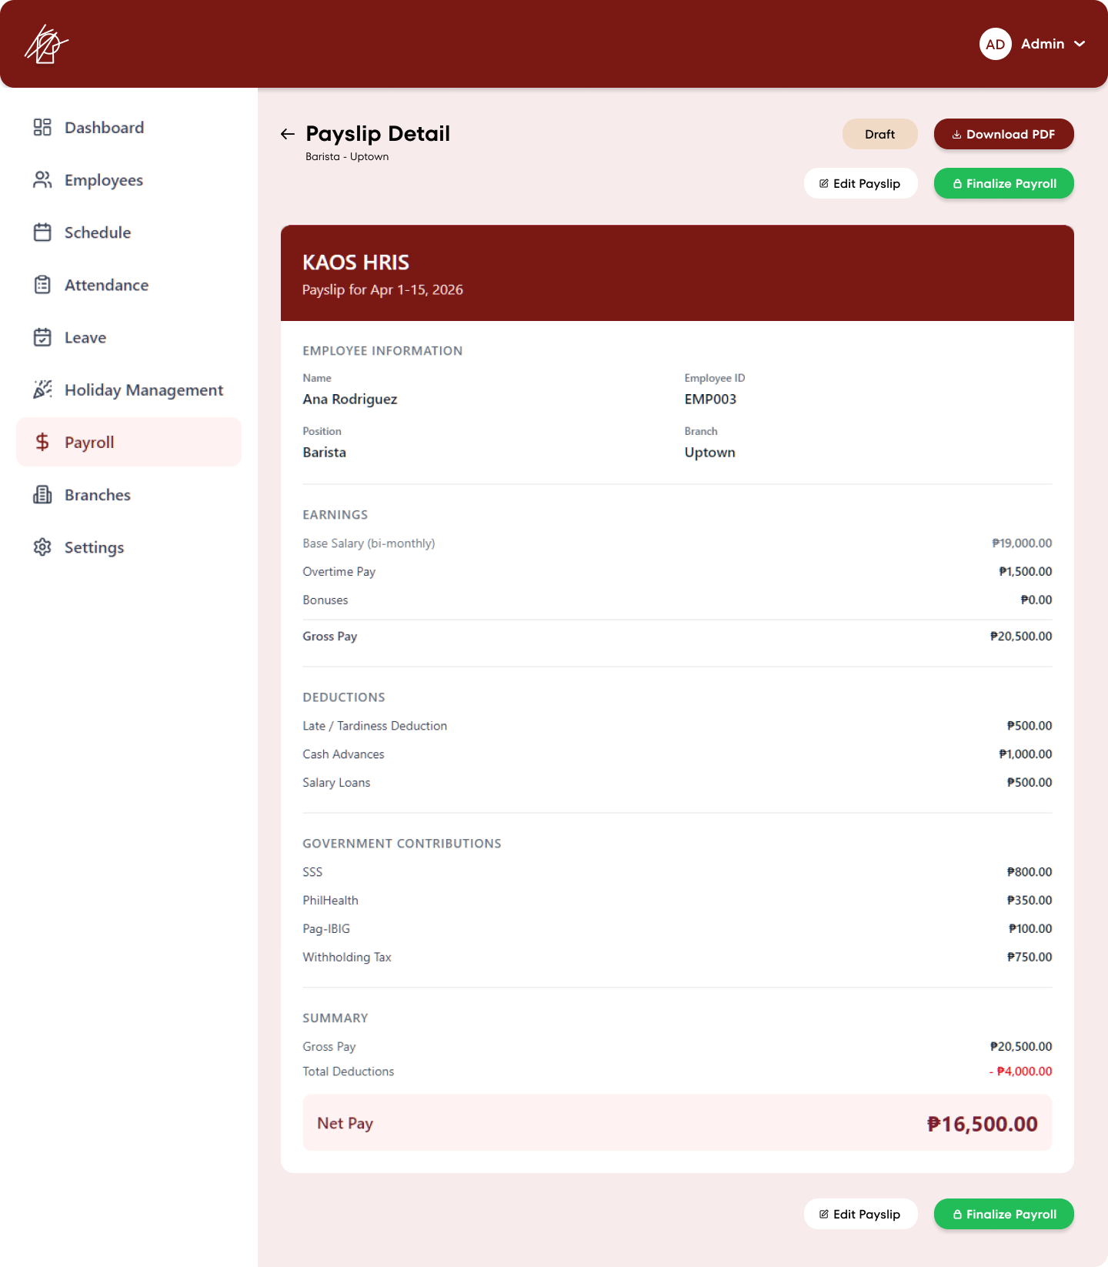
Figure 3.7.2.1. Payslip Detail
This is the detailed payslip view that appears when the admin clicks on a specific payroll period from an employee’s payroll history. It shows the full breakdown including employee information, earnings, deductions, government contributions, and the final net pay. Options to edit, download as PDF, or finalize the payroll are available.

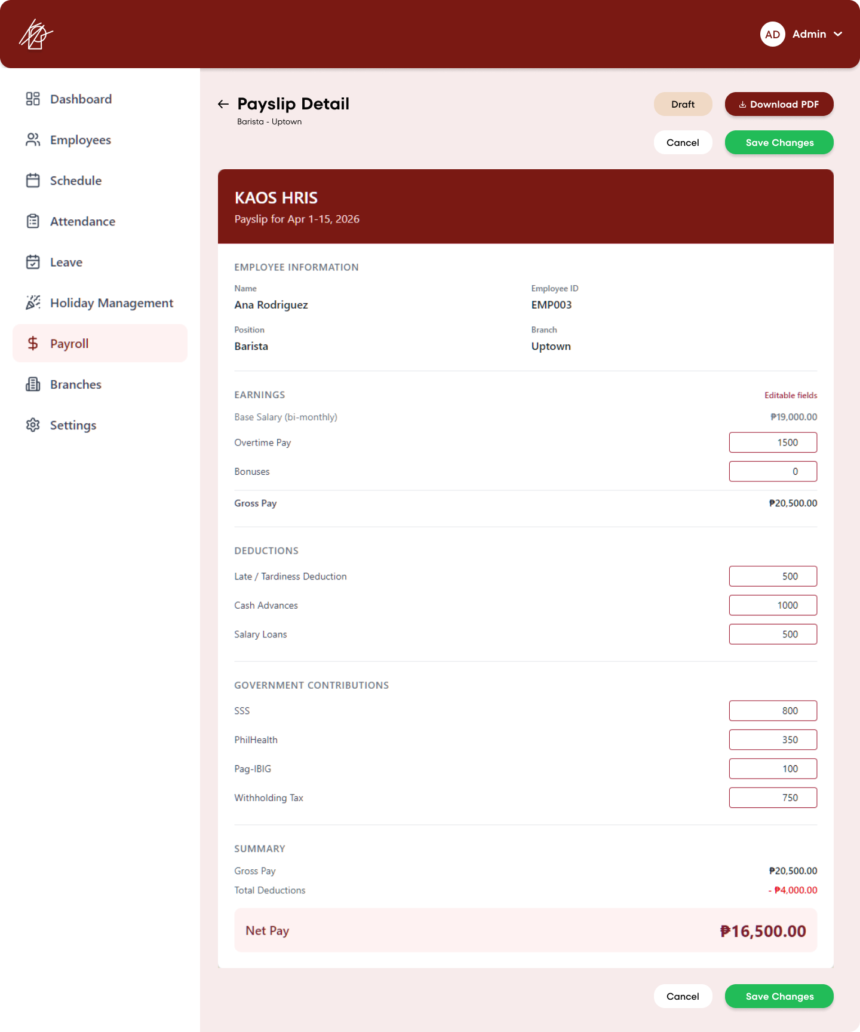
Figure 3.7.2.1.1. Edit Payslip
This is the editable version of the payslip detail screen. When the admin clicks "Edit Payslip," the earnings, deductions, and government contributions become editable fields. The admin can modify values such as Overtime Pay, Bonuses, Late/Tardiness Deduction, Cash Advances, Salary Loans, and government contributions, then save the changes or cancel.
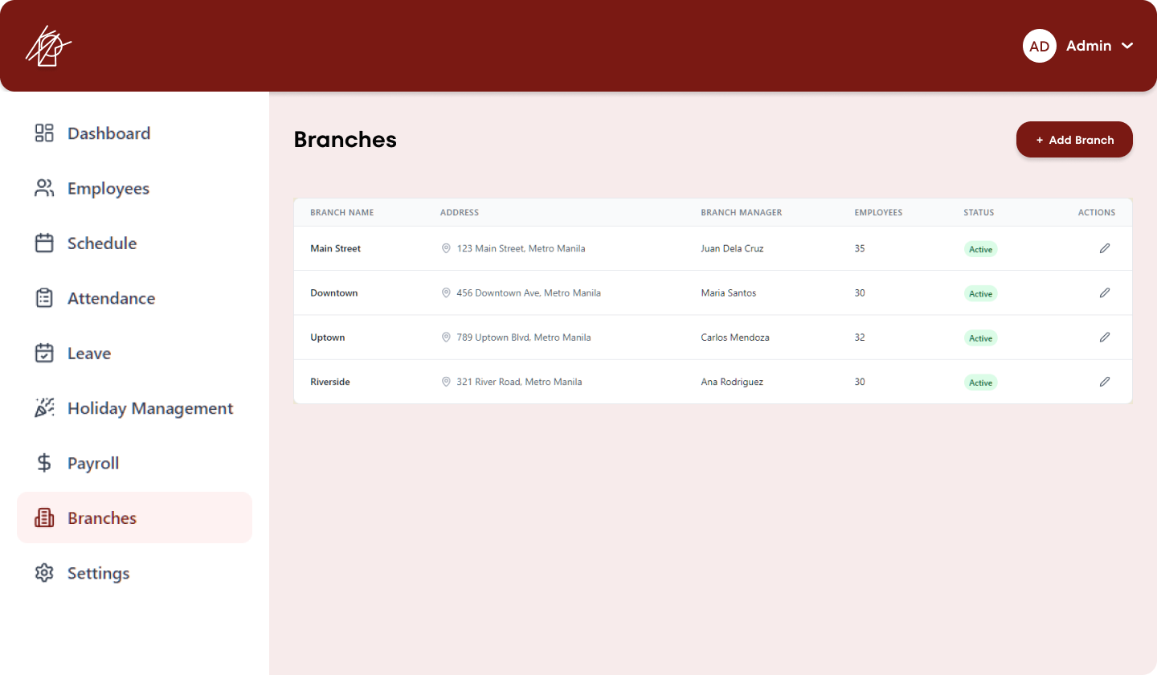
Figure 3.8. Branches Management
This is the Branches management page in the KAOS Portal admin panel. It displays all branches as cards showing the branch name, status (Active/Inactive), full address, branch manager, and number of employees. Admins can edit each branch or add a new one using the "+ Add Branch" button.
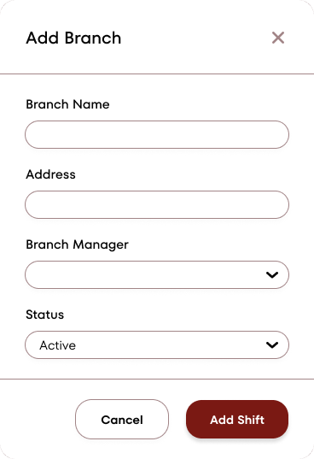
Figure 3.8.1. New Branch Form
This is the pop-up form that appears when the admin clicks the "+ Add Branch" button on the Branches page. It allows the admin to create a new branch by entering the branch name, address, branch manager, and status before saving.
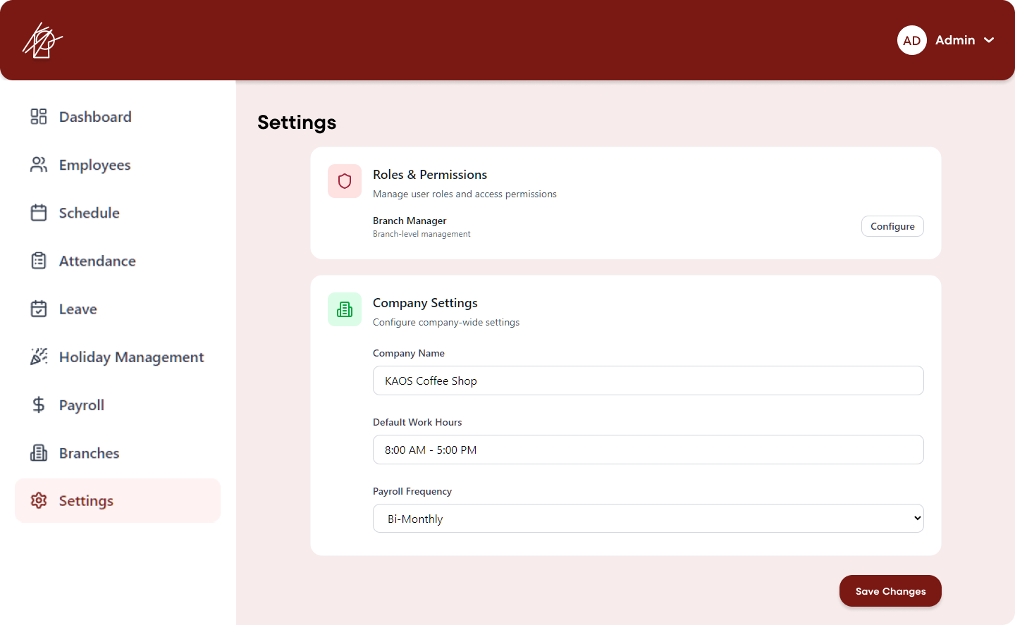
Figure 3.9. Settings & Configuration
This is the Settings page in the KAOS Portal admin panel. It provides access to three main sections:
- Roles & Permissions – Configure Branch Manager access levels
- Notifications – Enable/disable alerts for late arrivals, missing time-outs, and payroll reminders
- Company Settings – Edit company name, default work hours, and payroll frequency
Admins can save changes from this central settings hub.
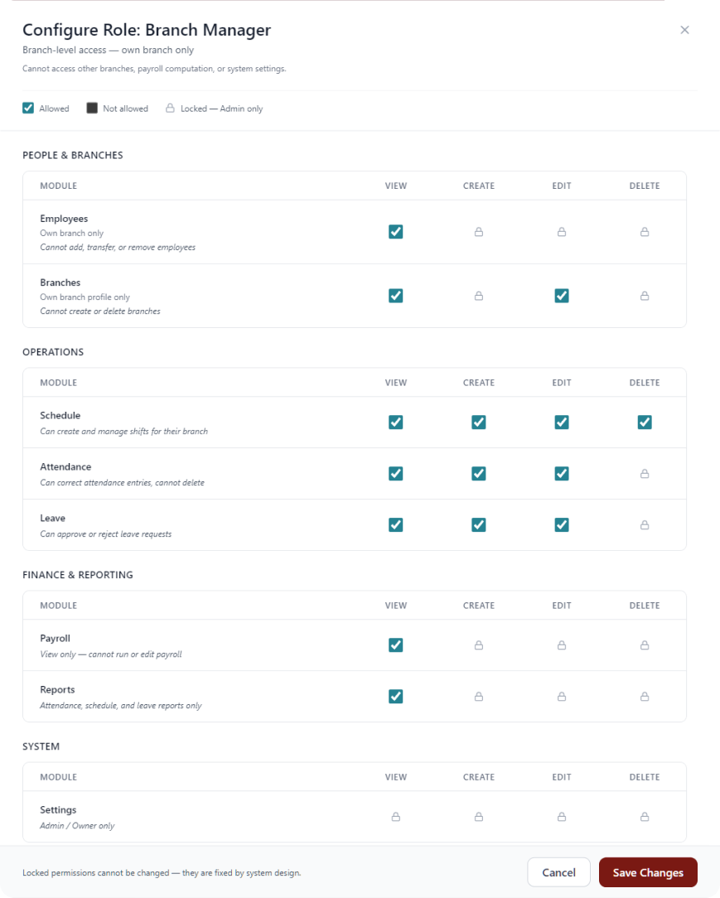
Figure 3.9.1. Configure Branch Manager Role
This pop-up allows the admin to configure permissions for the Branch Manager role. It displays a detailed permission matrix showing what a Branch Manager can and cannot do across different modules (People & Branches, Operations, Finance & Reporting, and System). Permissions are set at the branch level only, with clear restrictions on accessing other branches, running payroll, or modifying system settings.

